**Problem Solving**

Date : 26.07.2023

**Problem Statement**

Find the area() & perimeter() in different shapes

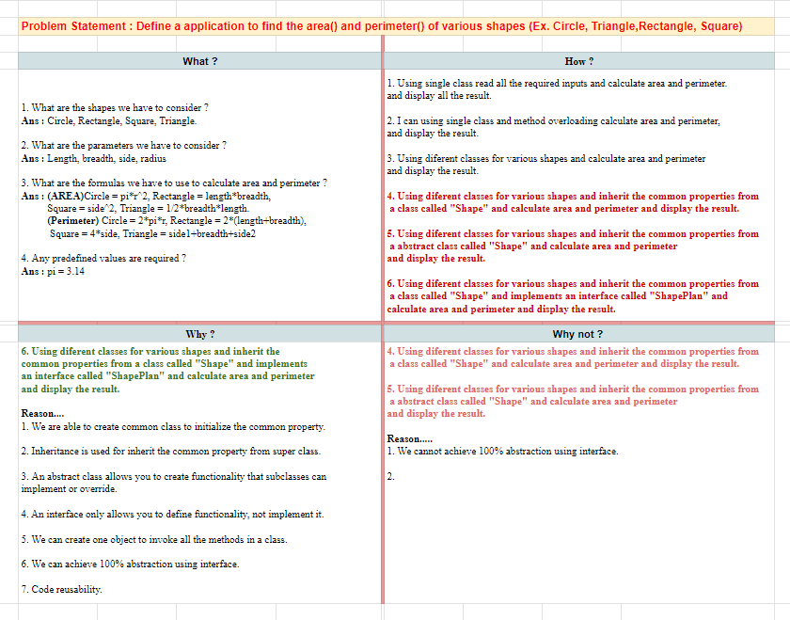

**Algorithm**

**Step 1 :** Start

**Step 2 :** Define an interface “ShapePlan” with abstract methods are area() & perimeter().

**Step 3:** Create abstract class “Shape” and implement the interface “ShapePlan” and create abstract methods.

**Step 4 :** Create a concrete class “Square,Triangle, Rectangle, Circle” and extend abstract class “Shape”.

**Step 5 :** In every concrete class, declare & initialize the variables and create a parameterized constructor respectively.

**Step 6 :** In every concrete class, inherit the abstract class methods to display the output.

**Step 7 :** Finally, in the main class, we create objects for every concrete method and invoke the respective methods.

**Step 8 :** Stop

**Program**

**package** com.gayathri.day;

//combination of interface,abstract,concrete class

**interface** ShapePlan {

**void** area();

**void** perimeter();

}

**abstract** **class** Shape **implements** ShapePlan {

**public** **abstract** **void** area();

**public** **abstract** **void** perimeter();

}

**class** Square **extends** Shape {

**int** side;

Square(**int** side)

{

**this**.side = side;

}

**public** **void** area() {

System.***out***.println("\nArea of square : " + (side * side));

}

**public** **void** perimeter() {

System.***out***.println("Perimeter of square : " + (4 * side));

}

}

**class** Rectangle **extends** Shape

{

**int** length, breath;

Rectangle(**int** length, **int** breath){

**this**.length = length;

**this**.breath = breath;

}

**public** **void** area() {

System.***out***.println("\nArea of rectangle : " + (length * breath));

}

**public** **void** perimeter() {

System.***out***.println("Perimeter of rectangle : " + (2 * (length + breath)));

}

}

**class** Triangle **extends** Shape {

**float** length1, length2, height;

Triangle(**float** length1, **float** length2, **float** height) {

**this**.length1 = length1;

**this**.length2 = length2;

**this**.height = height;

}

**public** **void** area() {

System.***out***.println("\nArea of triangle : " + (0.5 * length1 * height));

}

**public** **void** perimeter() {

System.***out***.println("Perimeter of rectangle : " + (length1+height+length2));

}

}

**class** Circle **extends** Shape {

**float** radius;

**public** Circle(**float** radius) {

**this**.radius = radius;

}

**public** **void** area() {

System.***out***.println("\nArea of circle : " + (3.14 * radius * radius));

}

**public** **void** perimeter() {

System.***out***.println("Perimeter of circle : " + (2 * 3.14 * radius));

}

}

**public** **class** DifferentShapes {

**public** **static** **void** main(String[] args) {

Square s = **new** Square(5);

s.area();

s.perimeter();

Rectangle r = **new** Rectangle(2,4);

r.area();

r.perimeter();

Triangle t = **new** Triangle(3.0f, 3.0f, 3.0f);

t.area();

t.perimeter();

Circle c = **new** Circle(5);

c.area();

c.perimeter();

}

}

**Output**

